CSULB — College of Engineering
Computer Engineering
Final Individual Report
CECS 490A
Author: Rodrigo Becerril Ferreyra
Teammates: Colton Curtis, Ethan Hua, and Kevin Nguyen
Professor Dan Cregg
07 December 2021
Table of Contents
Executive Summary 3
Responsibilities 4
Overall Progress Report 5
Expected Final Grade 5

Executive Summary
I am part of Group 7, which consists of Colton Curtis, Ethan Hua, and Kevin Nguyen. Our senior project is the Aftermarket Car Security System, or ACSS for short. The ACSS gives the user peace of mind by allowing him or her to install a fully-functional security system on top of his or her car. The ACSS uses many different sensors (ultrasonic, gyroscope, accelerometer, camera, Bluetooth) to determine if there is suspicious activity around the user’s car; “suspicious activity” is defined as theft or damage (intentional or unintentional). The security system automatically records and stores security footage for the user’s convenience, and has built-in speakers for alerting (unintentional) perpetrators to leave a note with drivers’ license and insurance information. The user will be able to see sensor data and camera feeds from a purpose-built website that can be accessed from desktop and mobile environments.
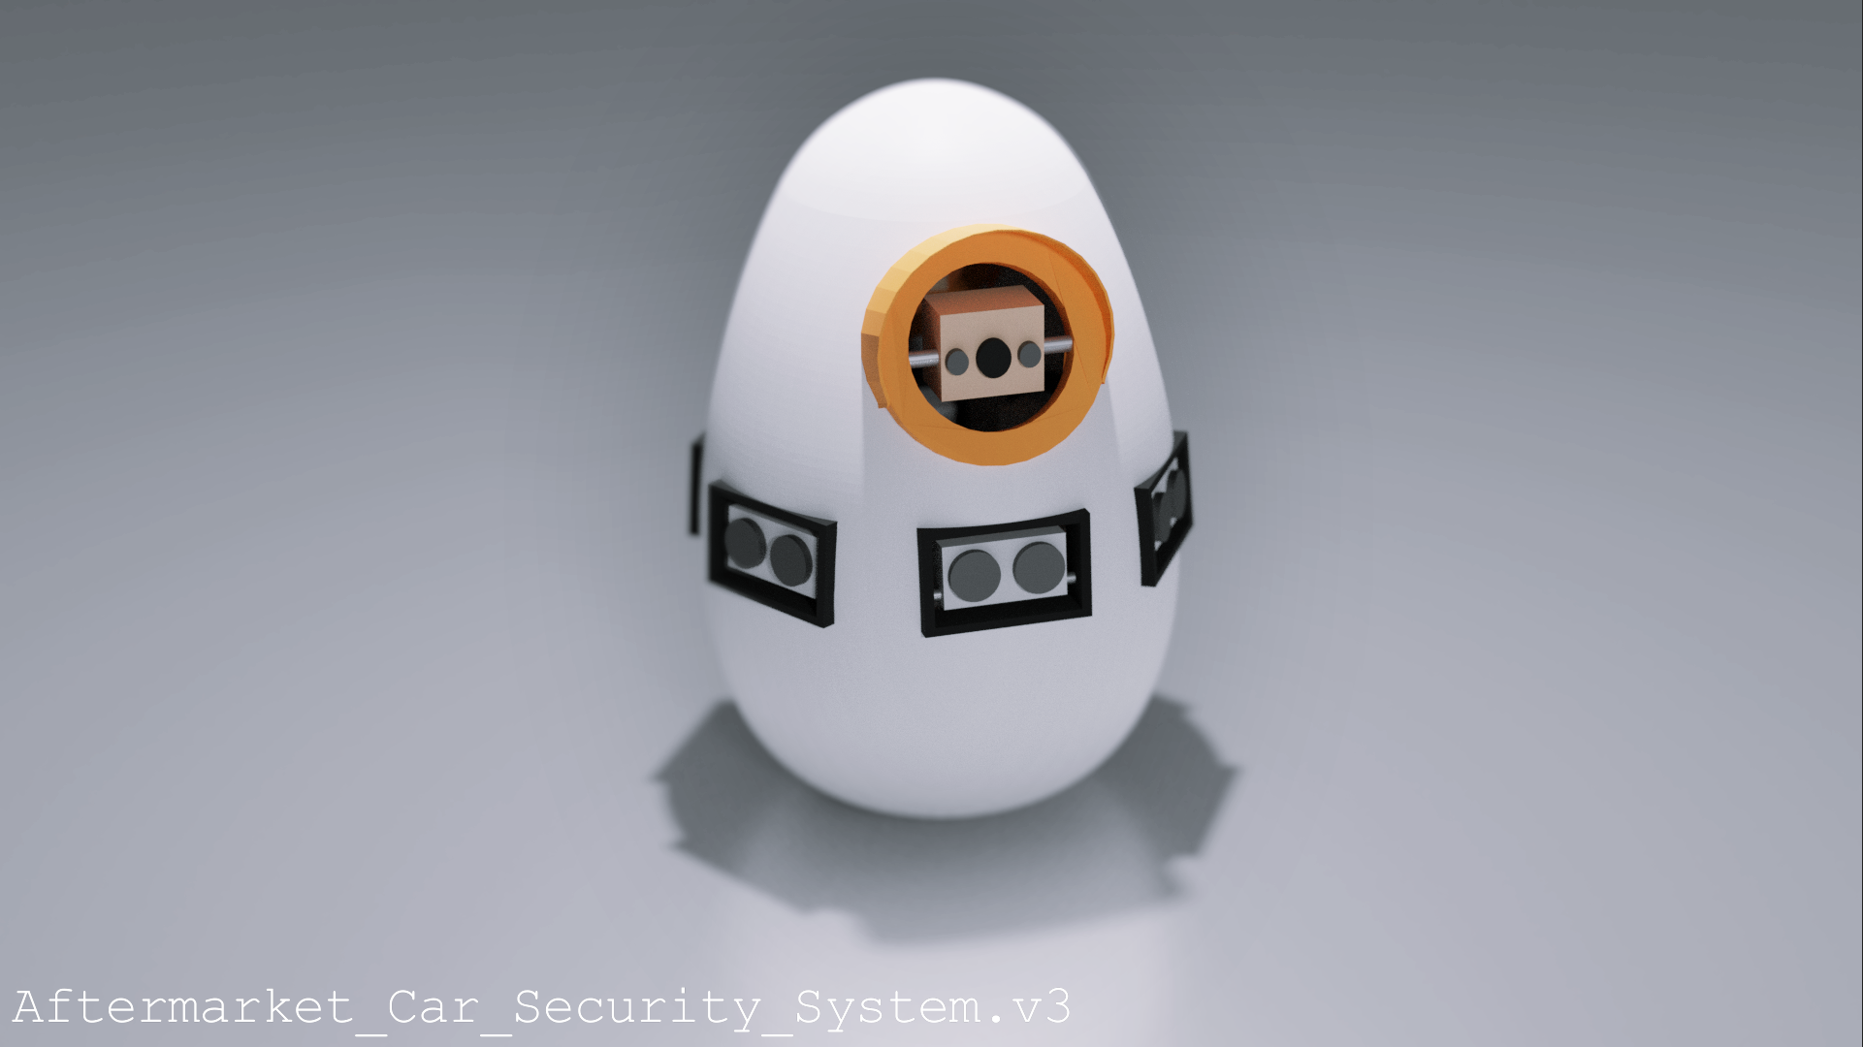Figure 1: Our updated model for the ACSS. Model by Colton Curtis.

Responsibilities
I was in charge of various tasks throughout the semester. While my roles varied, I was mainly in charge of machine vision, and to a lesser extent, livestreaming technologies and getting the video feed onto the website.
Machine vision is using a computer to figure out what is present in an image or video. In our case, we will be using machine vision to determine whether or not there is a person on camera. This, along with corroboration with other sensors such as the ultrasonic sensors, can theoretically give a smaller amount of false positives (alarm going off when nothing is happening). One way this can be done is by acquiring machine vision data periodically; if the same person is continuously detected over a certain period of time, we can flag suspicious behavior and perhaps send an alert to the user. It was my job this semester to research, install, implement, and test a multitude of machine vision algorithms for the team to use.
Another one of my important roles was to find a way to embed our Raspberry Pi cameras on the website. This feature is very important as well; it allows the user to verify if the situation is something to take note of and report to the police, or if it is simply a false alarm (false positive). Having live video on the website allows the user to have peace of mind when leaving his or her car parked. For this purpose, we will be using AWS Kinesis. This service allows us to take raw video footage and push it onto the website for the user to view, as well as save it onto AWS S3 to store it for later. This feat is more challenging than it seems, however. I am in charge of working with the other teammates that are working on other AWS technologies to integrate Kinesis into our website seamlessly. I am also in charge of building the Kinesis app using the given SDK in order to interface our Pi cameras with AWS.

Overall Progress Report
I think our team did a very good job planning and preparing for next semester. We have already tested many (if not all) of the technologies we will be using in our final product such as sensors, algorithms, and cloud services. All the tests we have performed were done in isolation, however, which means that we may run into issues in timing or processing power. We have a model that is ready to be 3D-printed at the beginning of next semester so we can start building and fitting components right away.
We are also ready to being building the second big part of our project, that being our website. Mostly all the AWS cloud services have been tested successfully and are ready to be put together into one website at the beginning of next semester. Our team will be working together to create a solid front-end and a working back-end to provide the best user experience we can.

Expected Final Grade
I expect to receive an A for this class. I think me and my team have achieved the goal of working “... in teams to define a problem, complete a design and provide both a written report and a multimedia presentation at the end of the semester.” We have definitely defined a problem, completed a design, and will give a presentation and a report at the end of the semester. However, simply completing the goals does not mean that the team should get an A.
Getting an A implies going above and beyond what was expected and simply completing all the work that was given. The reason I believe I deserve an A is because of my team’s drive and problem-solving capabilities. In the duration of the semester, we were hit by many different obstacles that we were not expecting. For example, it turned out to be quite difficult to join two video streams together, but we solved the problem by simply sending out two video streams. Later, if we need to, we can put them together using AWS or simply place them next to each other on our website. There are many more examples of going above and beyond, but I firmly believe that I deserve an A in this class.

